# **Tasks**

**Objective Questions**:

## What is the total no. of tables present in the data?



## What is the total no. of attributes present in the data?



## How many categorical columns are there in the data? [Search about categorical and continuous data, and try to answer this question] .

## 

## The data consists of some inconsistent and missing values so ensure that the data used for further analysis is cleaned.



## Using the LookUp functions, fill up the countries in the original data using the country code.



## Create a table to represent the number of restaurants opened in each country.

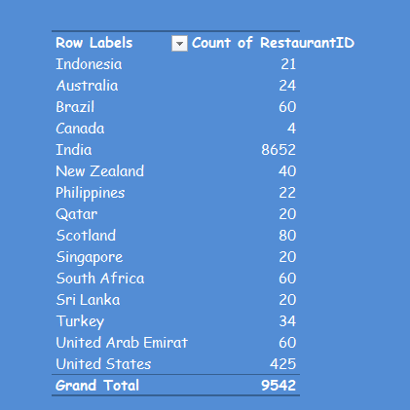

## Also, the management wants to look at the number of restaurants opened each year, so provide them with something here.

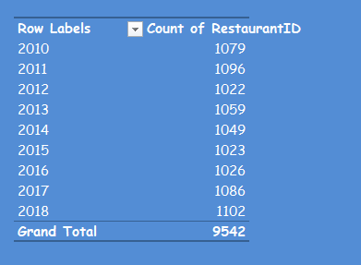

## What is the total number of restaurants in India in the price range of 4?



Used formula : “=COUNTIFS('Table 1 '!P2:P9543,4,'Table 1 '!W2:W9543,"India") ”

## What is the average number of voters for the restaurants in each country according to the data?

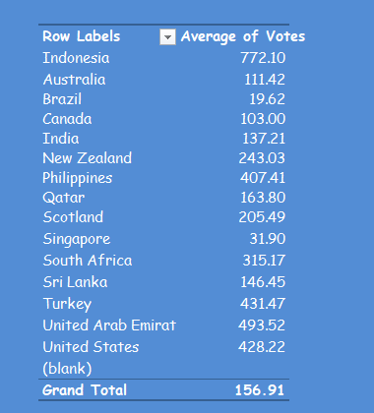

## Calculate the average rating for all the restaurants that have price_range < 4 and provide online delivery. Use only the “IF” function, Logical Operators, and Aggregation functions to solve this problem. [Note: Don’t use Conditional aggregation in this question.]



used formula :   
  
“{=AVERAGE(IF(('Table 1'[Has_Online_delivery]="Yes")*('Table 1'[Price_range]<4),'Table 1'[Rating]))}”  
  
i.e “{=AVERAGE(IF(('Table 1 '!M2:M9543="Yes")*('Table 1 '!P2:P9543<4), 'Table 1 '!S2:S9543))}”

## Using Conditional formatting highlight the rows of restaurants that are located in the countries or cities that you’ve suggested to the management for opening new restaurants.



## Create a new customized price column that consists of the abbreviation/symbol of the currency along with the Average_cost_for_two value. [Use string operations to do this task]

## How can you create an array formula in Excel or Google Sheets to count the number of restaurants listed that do not offer online delivery, are in the lowest price range, and have an average cost for two people less than or equal to 250 Indian Rupees?

## 

Used formula : {=SUM(( 'Table 1 '!M2:M9543 = "No") * ( 'Table 1 '!P2:P9543 = 1) * ( 'Table 1 '!X2:X9543 <= 250))}

also before leaving the cell there is combination to apply the array formula ctrl + shift + enter to apply array formula .

**Subjective Question:**

1. Suggest a few countries where the team can open newer restaurants with lesser competition. Which visualization/technique will you use here to justify the suggestions?

Finding the nation with the lowest competition is straightforward. To do this, use a PivotTable to add ratings to the rows, place the nation in the columns, and add the restaurant's ID to the values field. Next, select the nation with the fewest restaurants. These are the countries where new restaurants could be opened, offering high-quality service to provide customers with a fresh experience. Additionally, since the restaurants in these nations have very high ratings, it is advisable to offer online delivery services to enhance customer satisfaction.  
  
**Recommendations Extracted**

1. Open new restaurants to provide people a fresh experience.
2. Implement online delivery services, as high-rated restaurants in these nations suggest it could be beneficial.

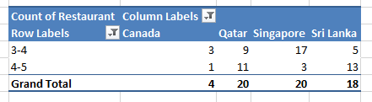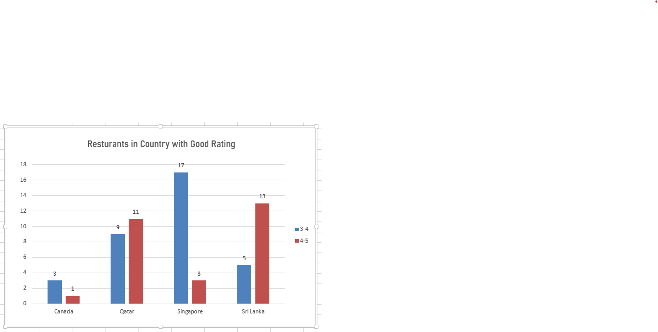**subjective Question chart**

1. Come up with the names of States and cities in the suggested countries suitable for opening restaurants.

To obtain the names of respondents in each nation, first include the country in the rows of the pivot table. Next, add the city beneath each country to categorize the cities within each nation. Finally, include the restaurant ID in the values section to achieve the desired outcome.

Cities with less competition include:

* **Canada:** Chatham-Kent, Vineland Station, Yorkton, Consort
* **Sri Lanka :** Colombo
* **Qatar :** Doha
* **Singapore** : Singapore

These cities are well-regarded and present opportunities with less competition. It is recommended that the corporation consider opening new restaurants in these locations, offering a diverse range of cuisine options and maintaining high-quality service.

**Recommendation:**

The corporation should consider opening new restaurants in the listed cities, focusing on offering diverse cuisine and high-quality service to leverage the lower competition and strong reputation of these locations.

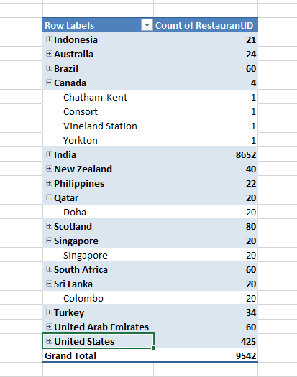

**subjective Question chart**

## According to the countries you suggested, what is the current quality regarding ratings for restaurants that are open there?

Singapore, Canada, Sri Lanka, and Qatar boast restaurants with generally positive ratings, averaging between 3 and 4 stars. These countries also exhibit a relatively competitive landscape compared to other regions. This combination makes them prime locations for launching cloud kitchens. Despite the moderate competition, there are ample opportunities to establish a successful restaurant chain in these markets.

### Recommendations:

1. **Establish cloud kitchens:** Given the favorable conditions, setting up cloud kitchens in these countries presents a promising business venture.
2. **Implement an online delivery service:** Complementing the cloud kitchens with a robust online delivery service can further enhance market penetration and customer convenience.

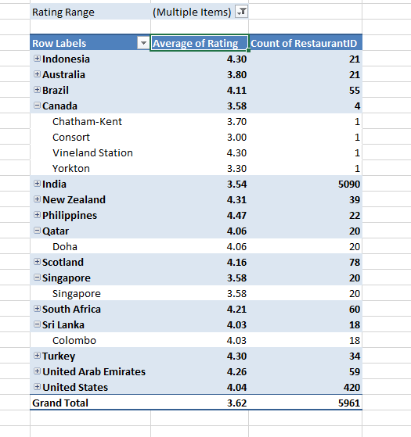 **subjective Question chart**

## Also, what is the current expenditure on food in the suggested countries, so we can keep our financial expenditure in control?

In the recommended countries of Sri Lanka, Qatar, Canada, Singapore, and others, the average cost for two individuals dining out ranges from 2500 to 9500 rupees. Online delivery services present significant profit potential due to the substantial average order values in these regions. While individuals may spend more on dining out, they could also choose to allocate those funds towards a comfortable home-cooked meal. Given the relatively lower competition among Zomato-partnered restaurants, the company could strategically align itself with these establishments to attract more customers. By fostering exclusive partnerships, Zomato could potentially establish a dominant market position in specific areas.

**Recommendations:**

1. **Strengthen Restaurant Partnerships:** Zomato should actively seek and cultivate stronger partnerships with restaurants in these regions. This could involve offering exclusive deals, marketing support, and other benefits to encourage restaurant participation.
2. **Launch Targeted Coupons and Offers:** Implementing targeted coupons and offers on the Zomato app can attract more customers and increase order frequency. These promotions can be tailored to specific demographics, regions, or restaurant types.
3. **Strategic Menu Management:** While inflating prices in a monopolistic market might be tempting, it could lead to customer dissatisfaction and potential backlash. A more sustainable approach would be to focus on optimizing the menu by offering unique, high-quality items that justify premium pricing. Additionally, strategic cross-selling and upselling techniques could enhance profitability without relying solely on price increases.

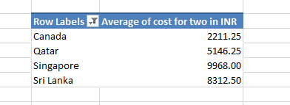

**subjective Question chart**

## Come up with the names of restaurants from the recommended states that are our biggest competitors and also those that are rated in the lower brackets, i.e. 1-2 or 2-3.

The table below lists restaurant names in the recommended nations that are competitors, with ratings between one and three. Some of these restaurants, located in prime areas, should be converted. Additionally, efforts should be made to improve their online listings and customer service. A small upfront investment can also be made to attract interest from the restaurant owners, including menu adjustments to feature higher-priced items.

**Recommendations :**

1. Focus on converting restaurants in prime locations.
2. Improve online listings and customer service for these restaurants.
3. Make a small upfront investment to attract restaurant owners' interest.
4. Adjust menus to include more expensive items to increase profitability.

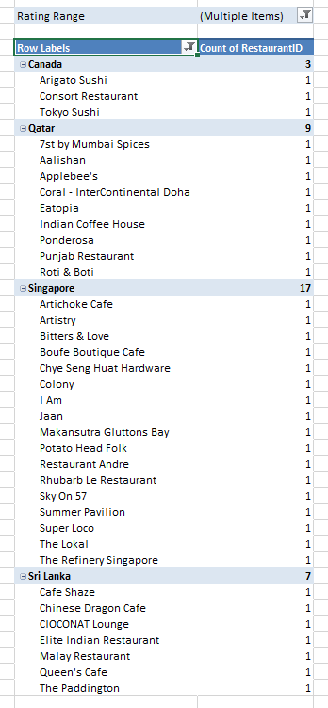

**subjective Question chart**

## Which cuisines should we focus on in the newer restaurants to get better feedback? Does the choice of cuisines affect the restaurant ratings?

The table below shows that people typically enjoy multinational cuisines such as American, Chinese, and Indian. This suggests that individuals in these nations are open to trying new things. Therefore, in addition to offering regional cuisine, we can introduce popular international dishes. Furthermore, adding discount vouchers can help increase customer traffic to these restaurants. People who enjoy international cuisine also appreciate an international ambiance. Hence, an initial investment in creating such an environment could attract customers seeking a more global dining experience.  
  
**Recommendations :**

1. Introduce popular international cuisines (American, Chinese, Indian) alongside regional dishes.
2. Offer discount vouchers to increase customer traffic.
3. Invest in creating an international ambiance to attract customers who enjoy global dining experiences.

**subjective Question chart** 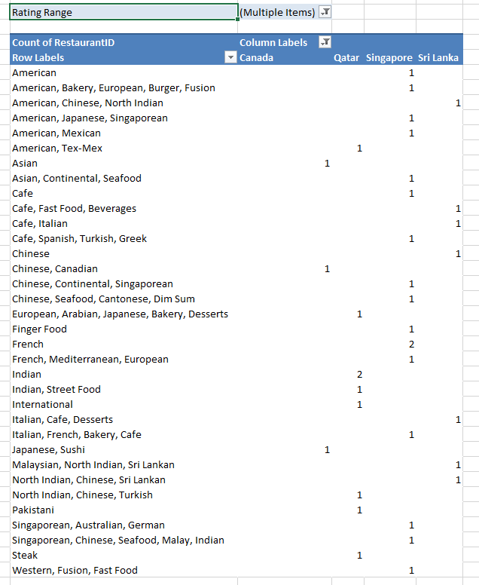

## According to our current data, should we go for online delivery and table booking? Does that affect the customer’s ratings?

The data reveals that countries without online delivery and table booking services have an average rating of 2.68, while those offering both services achieve a higher average rating of 3.60. This clearly indicates that providing online delivery and table booking significantly impacts customer satisfaction. In the suggested countries, the organization should prioritize offering these services to enhance consumer engagement. To attract more customers, it’s recommended to offer discount coupons and promotions, such as "Buy 2, Get 1 Free." Initially, the company can focus on affordability by minimizing profitability, and after a certain period, gradually increase profits by raising menu prices and introducing charges for additional services like online delivery.

### Key Recommendations:

1. **Provide online delivery and table booking** to boost customer satisfaction and ratings.
2. **Offer discount schemes** (e.g., "Buy 2, Get 1 Free") to attract customers and increase engagement.
3. **Minimize profitability initially** to offer affordable services and gain customer traction.
4. **Gradually increase prices and introduce charges for additional services** (such as online delivery) after gaining a customer base.

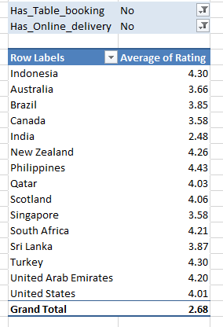

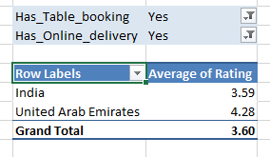 **subjective Question chart**

## Should the team keep the rate of cuisines higher? Will that affect the feedback? According to our data are the rates of cuisines and ratings, correlated?

Based on the observation, the correlation between the cost for two and the average rating is -0.02, indicating that customers perceive the pricing as not offering good value for money. In other words, people feel they are not getting their money’s worth. It is recommended that the company focus on enhancing the restaurant’s ambiance, maintaining hygiene, and implementing standardized operating procedures (SOPs) in unorganized restaurant chains. Additionally, offering promotions for dining out can improve the overall customer experience. For customers who prefer online orders, the company should consider offering "Free delivery after 30 minutes, "Buy 2, Get 1 Free”," discount coupons, and additional discounts for loyal customers to enhance their satisfaction.

### Key Recommendations:

1. **Enhance restaurant ambiance and maintain hygiene** to improve customer experience.
2. **Implement SOPs in unorganized restaurant chains** to ensure consistent service quality.
3. **Offer promotions for dining out**, such as discounts and special offers, to boost customer satisfaction.
4. For online customers, **introduce offers like "Free delivery after 30 minutes"**, "Buy 2, Get 1 Free," and discount coupons to increase engagement.
5. **Provide additional discounts for loyal customers** to encourage repeat business and customer loyalty.

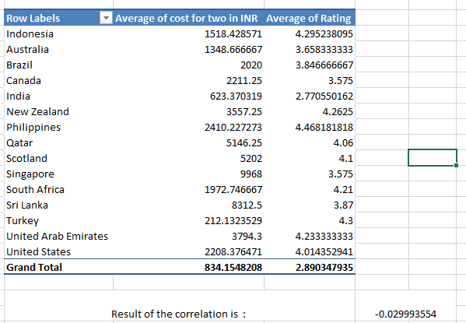

**subjective Question chart**

## What is the distribution of the number of restaurants of different price ranges in all the countries?

Data analysis reveals that India has the highest number of restaurants across various price ranges, followed by the USA. This suggests that countries with a diverse range of restaurant pricing are more likely to offer growth opportunities, as they cater to a wide range of consumer preferences. The variety of restaurants in these regions reflects dynamic consumer behavior. We could target low-rated restaurants already located in prime areas with high growth potential. By providing initial funding to improve their quality, service, and ambiance, we can help boost their ratings, gain their trust, and attract them to our platform. Additionally, we could help these restaurants establish an online presence. For cost-conscious customers, focusing on cloud kitchens can reduce production expenses, allowing for lower menu prices and better serving this customer segment.

### Recommendations:

1. **Target Growth Opportunities**: Focus on countries like India and the USA, which have a diverse range of restaurants, to tap into varied consumer segments.
2. **Improve Low-Rated Restaurants**: Partner with low-rated restaurants in prime locations, providing resources to improve quality, service, and ambiance, which could enhance their ratings and growth potential.
3. **Platform Attraction**: Bring improved restaurants onto the platform by gaining their trust and offering value, such as helping them establish an online presence.
4. **Cloud Kitchens for Budget Customers**: Set up cloud kitchens to reduce production costs and offer lower menu prices, catering to cost-sensitive customers.

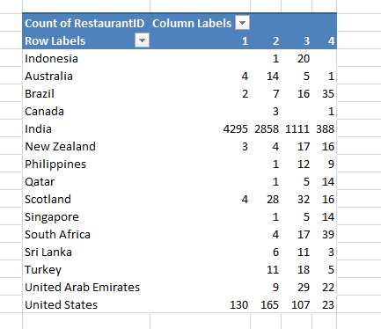

**subjective Question chart**

## Explain your approach in brief for suggesting countries/cities in order to open new restaurants, if the objective and subjective questions would have not been given to assist you. **[you have to give bullet pointers in order to answer this question]**

1. Pick the restaurants with better reviews for their cuisines and cities.   
2. Avoid investing in areas where the quality of the services has declined.   
3. Payed attention to nations where table reservations and internet delivery are available, as this boosts restaurant revenue.   
4. Concentrated on cities with high average costs for two.